**Courier Management System**

**Task 1:Schema**

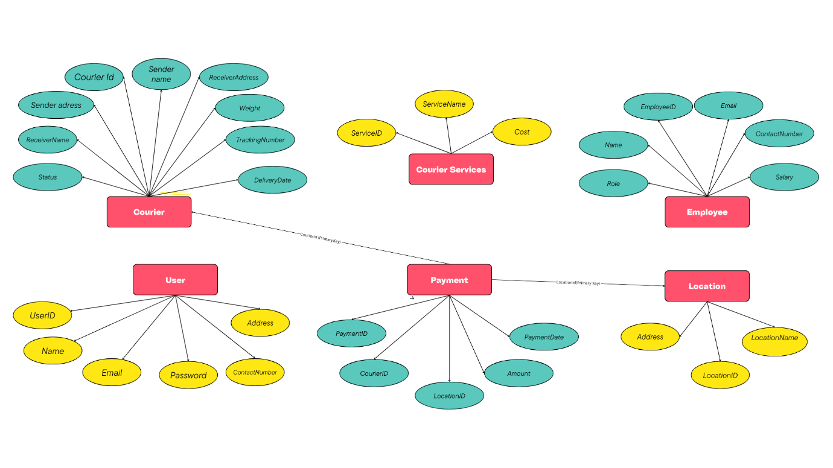

**Structure of the table**

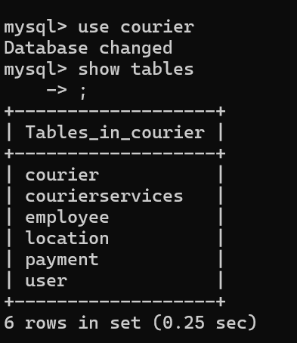

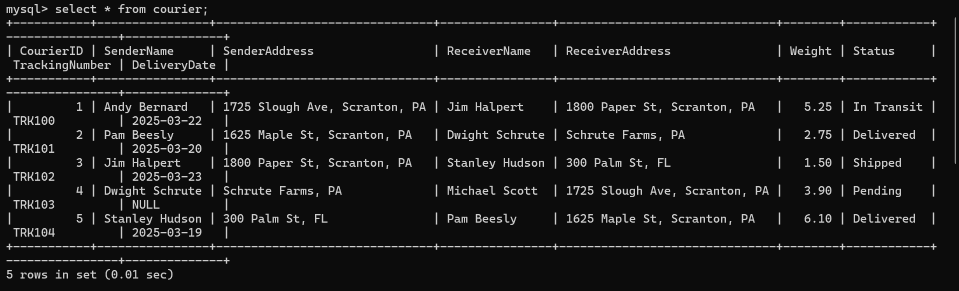

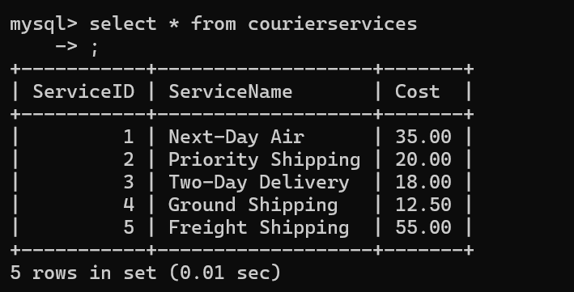

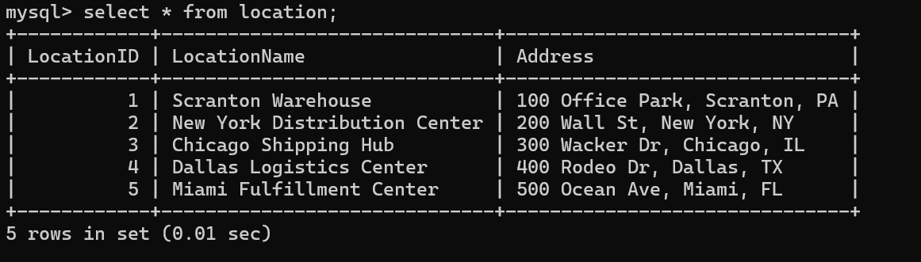

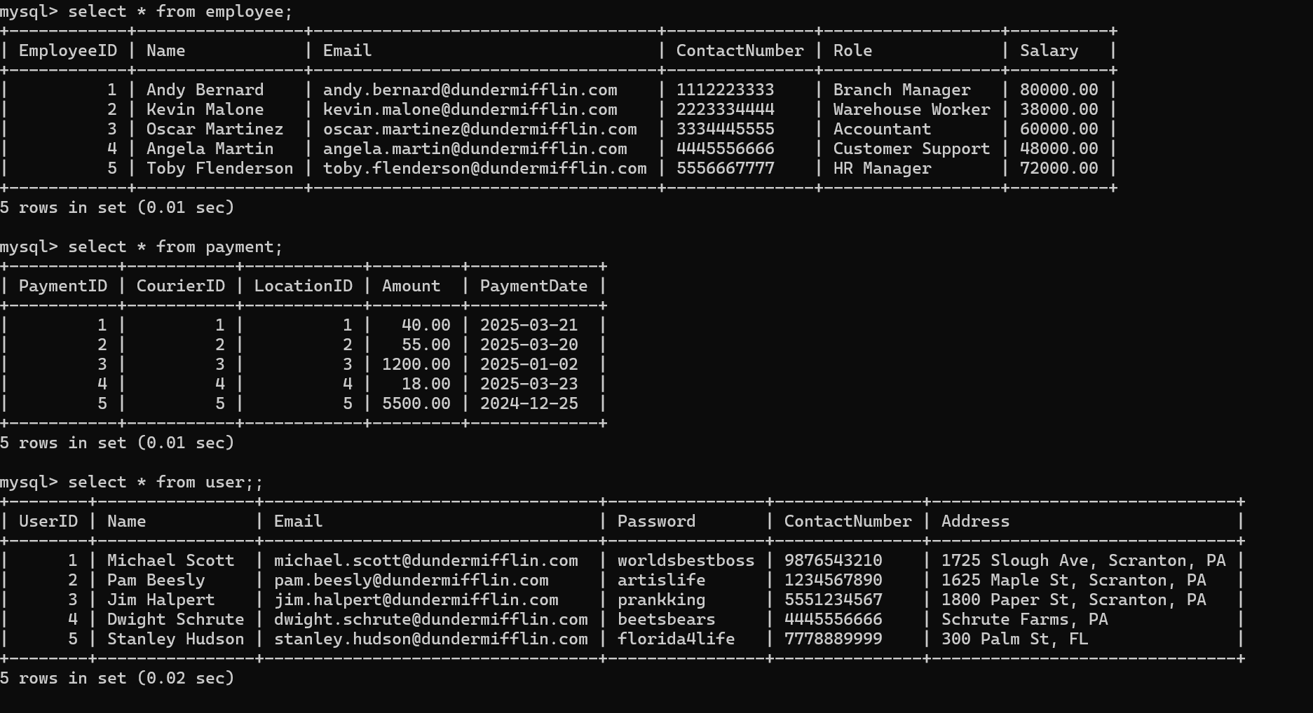

**Task 2: Select,Where**

1. List all customers:

Ans:

select * from User;

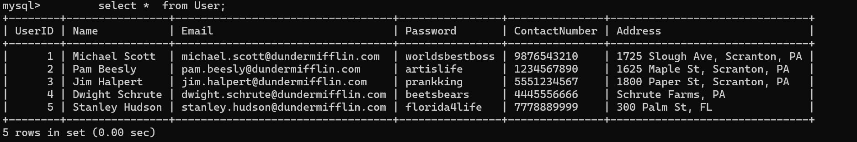

2. List all orders for a specific customer:

Ans:

select * from Courier where SenderName = 'Michael Scott';

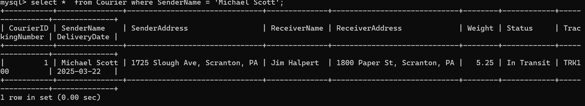

3. List all couriers:

Ans:

select * from Courier;

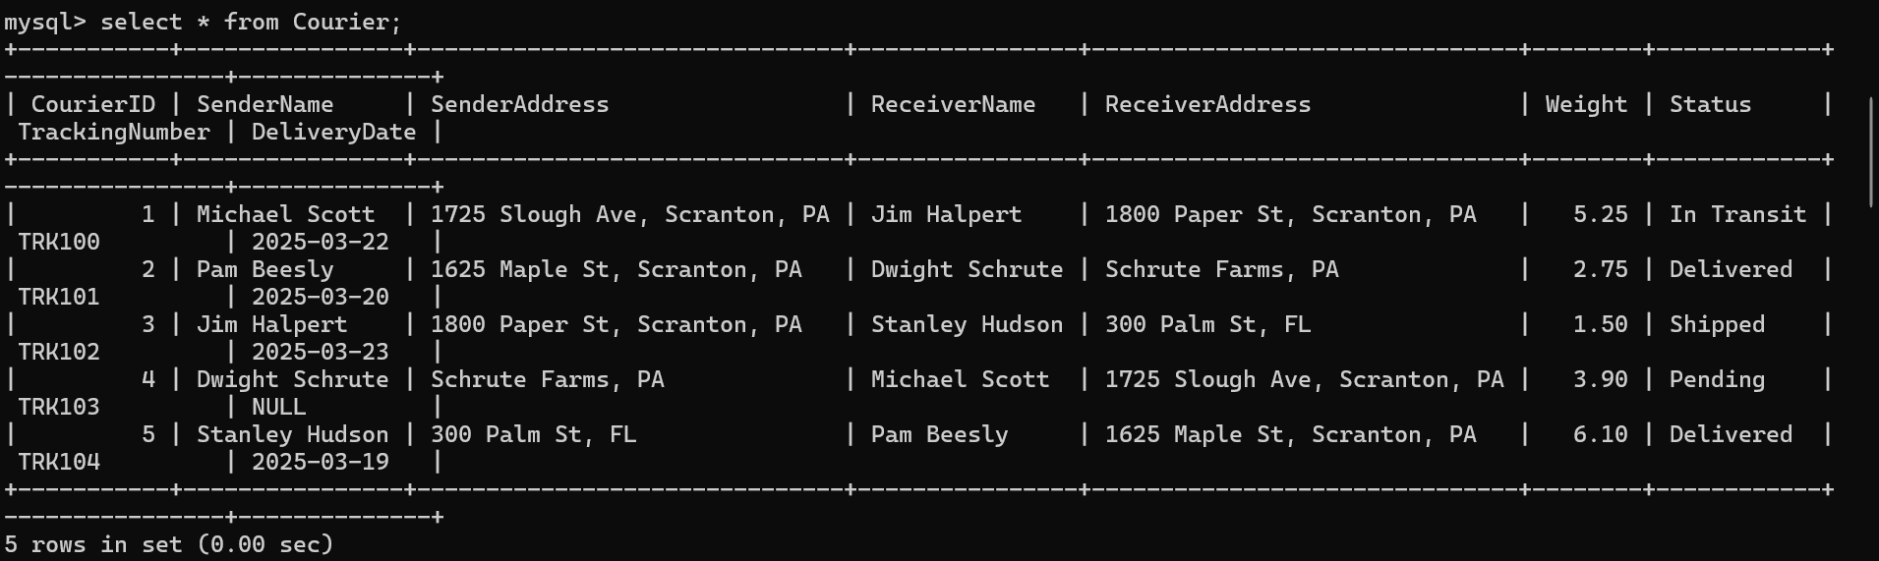

4. List all packages for a specific order:

Ans:

Select* From Courier

Where CourierID = 1;

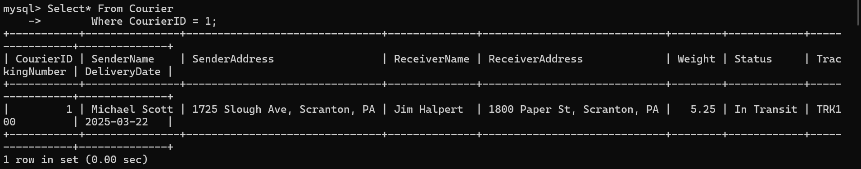

5. List all deliveries for a specific courier:

Ans:

Select * From Courier

Where Status = 'Delivered' And CourierID = 5;

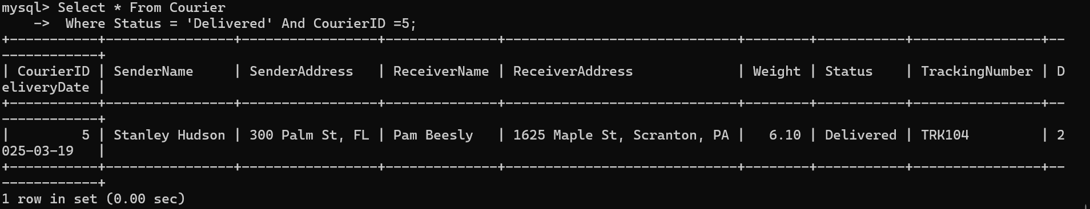

6. List all undelivered packages:

Ans:

Select * From Courier

Where Status != 'Delivered';

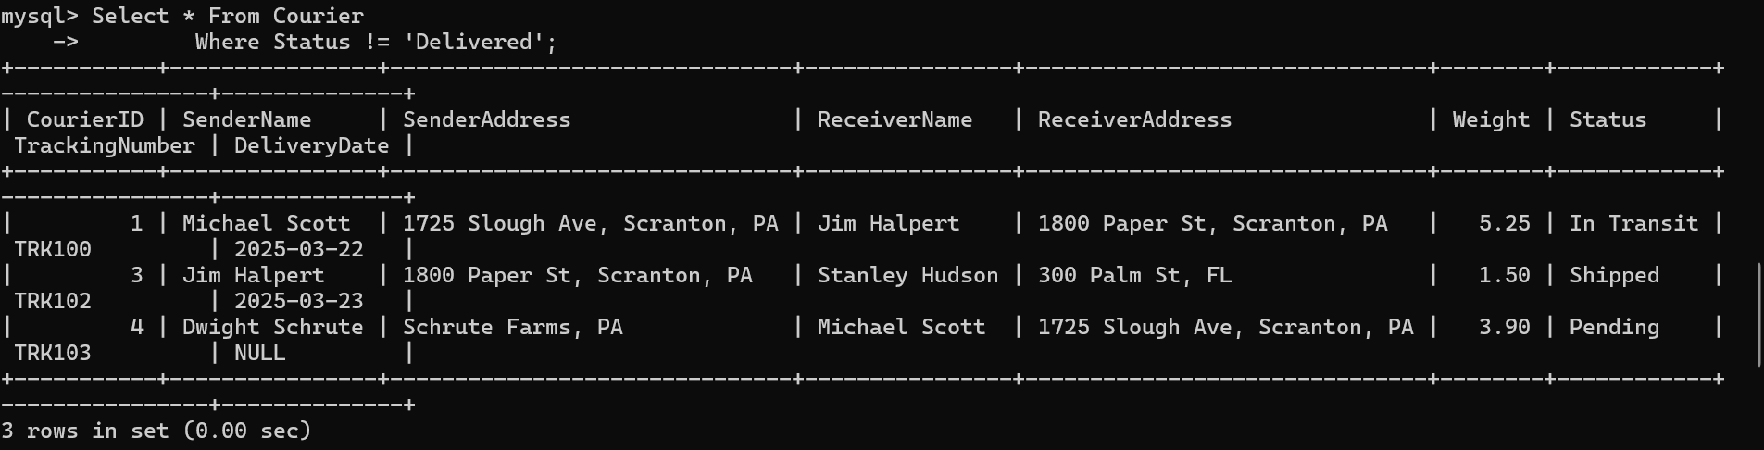

7. List all packages that are scheduled for delivery today:

Ans:

Select * From Courier

Where DeliveryDate = Curdate();

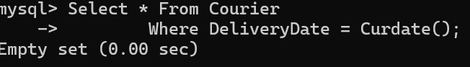

8. List all packages with a specific status:

Ans:

Select * From Courier

Where Status = 'In Transit';

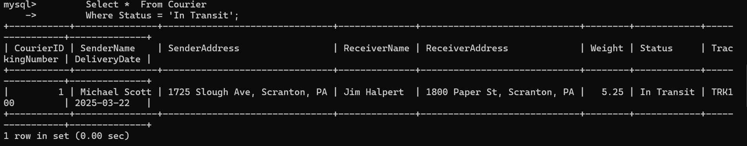

9. Calculate the total number of packages for each courier.

Ans:

Select CourierID, Count(*) AS TotalPackages From Courier

Group by CourierID;

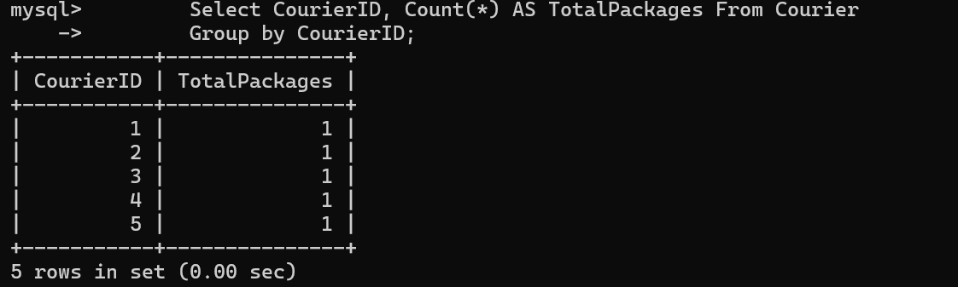

10. Find the average delivery time for each courier

Ans:

Select CourierID,

avg(datediff(DeliveryDate, Now())) as AvgDelivery

From Courier Where Status = 'Delivered' Group By CourierID;

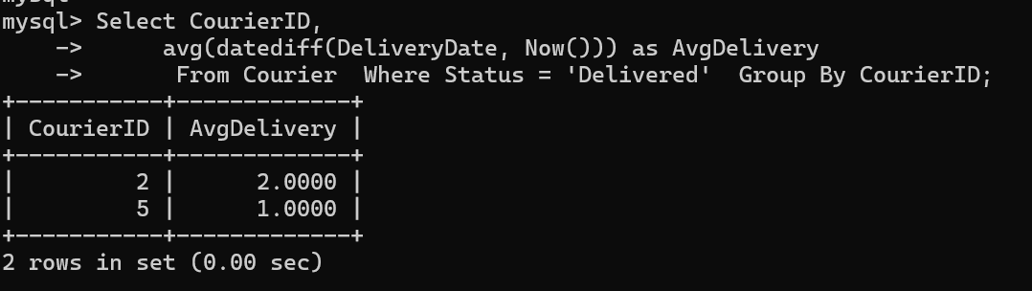

11. List all packages with a specific weight range:

Ans:

Select * From Courier

Where Weight Between 5.00 And 10.00;

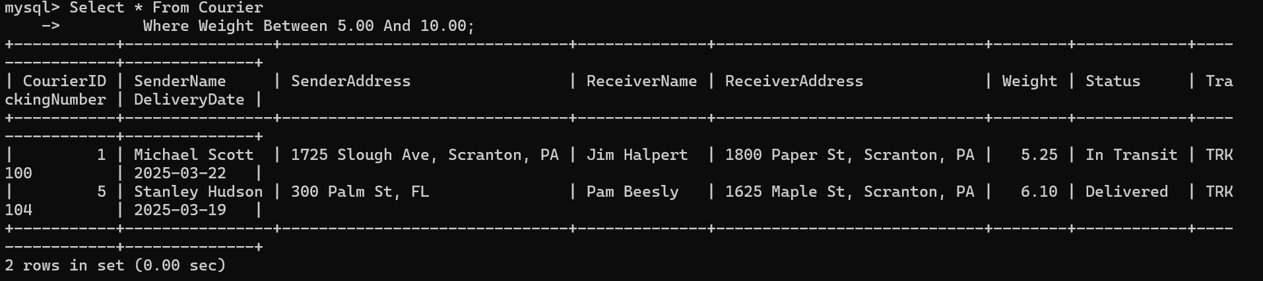

12. Retrieve employees whose names contain 'John'

Ans:

Select * From Employee

Where Name Like '%John%';



13. Retrieve all courier records with payments greater than $50.

Ans:

Select c.* From Courier c

Join Payment p on c.CourierID = p.CourierID

Where p.Amount > 50.00;

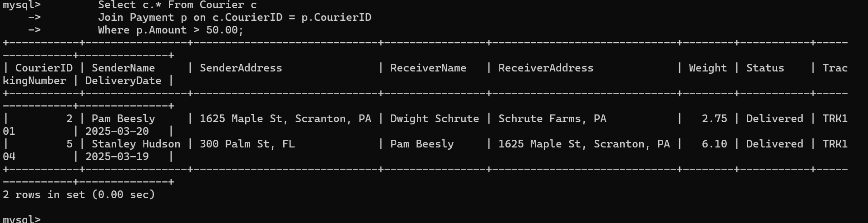

**Task 3: GroupBy, Aggregate Functions, Having, Order By, where**

14. Find the total number of couriers handled by each employee:

Select E.EmployeeID, E.Name, Count(C.CourierID) as TotalCouriers

From Employee E

Join Courier C on E.Name = C.SenderName

Group by E.EmployeeID, E.Name;

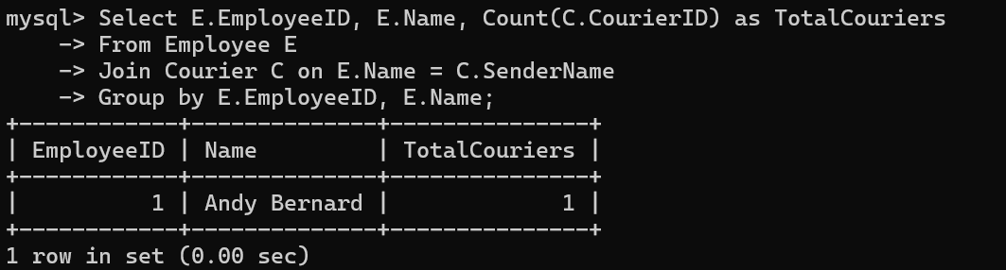

15. Calculate the total revenue generated by each location:

Select L.LocationID, L.LocationName, Sum(P.Amount) as TotalRevenue

From Location L

Join Payment P on L.LocationID = P.LocationID

Group by L.LocationID, L.LocationName;

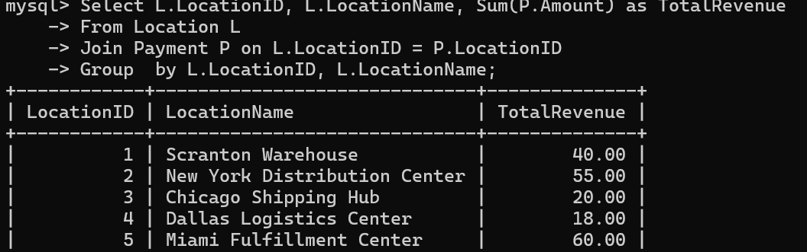

16. Find the total number of couriers delivered to each location:

Select L.locationid, L.locationname, Count(C.courierid) As Totaldelivered

From Location L

Join Payment P On L.locationid = P.locationid

Join Courier C On P.courierid = C.courierid

Where C.status = 'delivered'

Group By L.locationid, L.locationname;

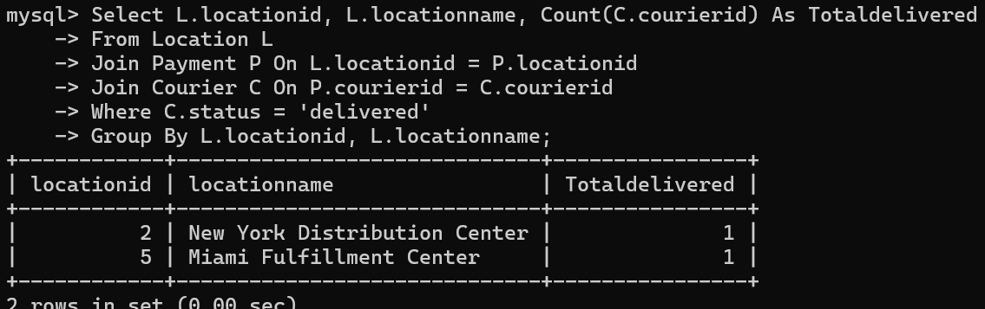

17. Find the courier with the highest average delivery time:

Select C.courierid, C.trackingnumber, Avg(Datediff(C.deliverydate, Now())) As Avgdeliverytime

From Courier C

Where C.status = 'delivered'

Group By C.courierid, C.trackingnumber

Order By Avgdeliverytime Desc

Limit 1;

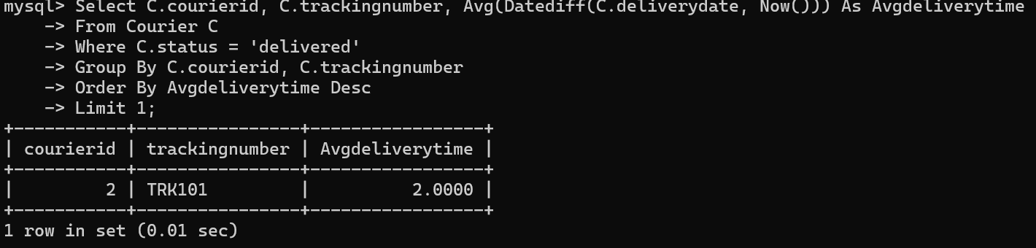

18. Find Locations with Total Payments Less Than a Certain Amount:

Select L.locationid, L.locationname, Sum(P.amount) As Totalpayments

From Location L

Join Payment P On L.locationid = P.locationid

Group By L.locationid, L.locationname

Having Totalpayments < 1000.00;

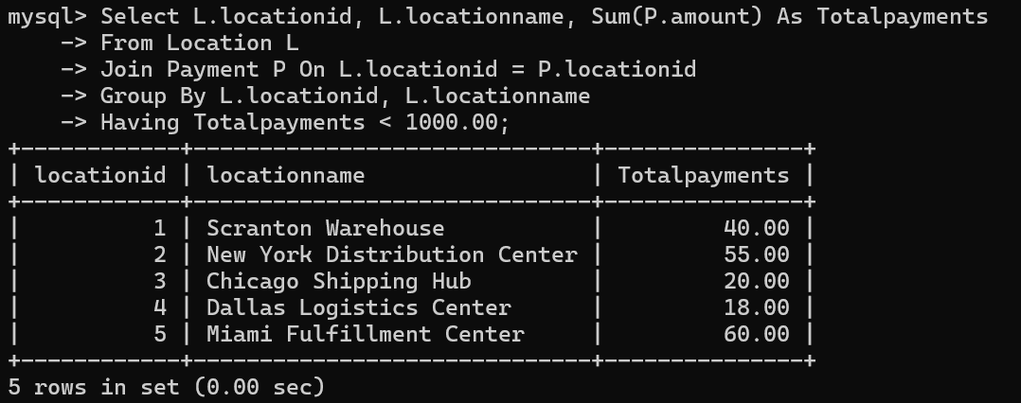

19. Calculate Total Payments per Location:

Select L.locationid, L.locationname, Sum(P.amount) As Totalpayments

From Location L

Join Payment P On L.locationid = P.locationid

Group By L.locationid, L.locationname;

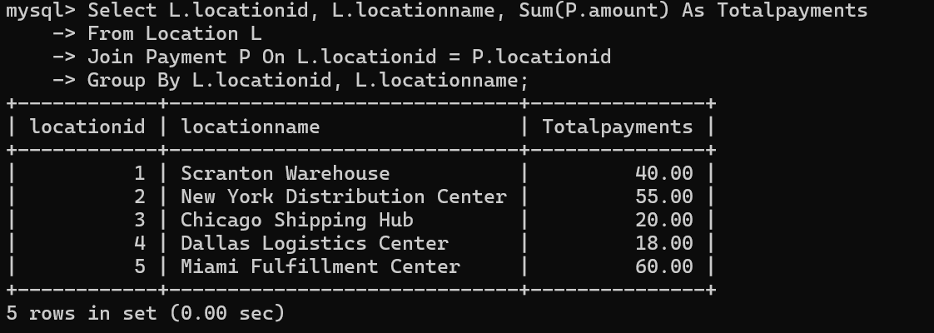

20. Retrieve couriers who have received payments totaling more than $1000 in a specific location

Select C.courierid, C.trackingnumber, Sum(P.amount) As Totalpayments

From Courier C

Join Payment P On C.courierid = P.courierid

Where P.locationid = 5

Group By C.courierid, C.trackingnumber

Having Totalpayments > 1000.00;

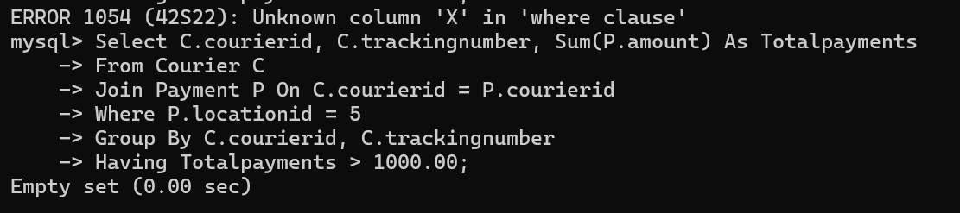

21. Retrieve couriers who have received payments totaling more than $1000 after a certain date

Select C.courierid, C.trackingnumber, Sum(P.amount) As Totalpayments

From Courier C

Join Payment P On C.courierid = P.courierid

Where P.paymentdate > '2025-01-01'

Group By C.courierid, C.trackingnumber

Having Totalpayments > 1000.00;

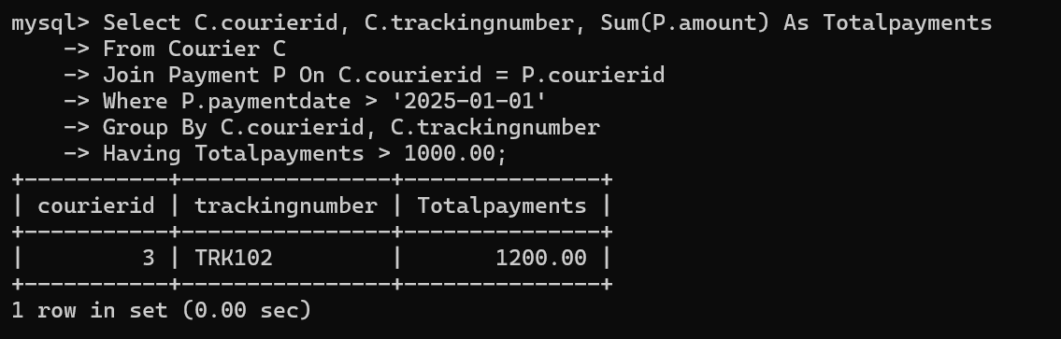

22. Retrieve locations where the total amount received is more than $5000 before a certain date

Select L.locationid, L.locationname, Sum(P.amount) As Totalpayments

From Location L

Join Payment P On L.locationid = P.locationid

Where P.paymentdate < '2025-01-01'

Group By L.locationid, L.locationname

Having Totalpayments > 5000.00;

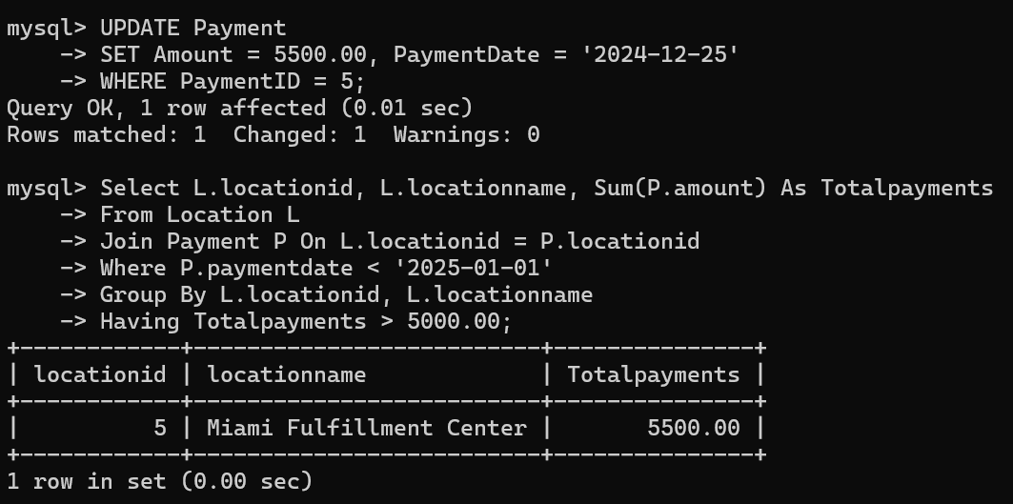

**Task 4: Inner Join,Full Outer Join, Cross Join, Left Outer Join,Right Outer Join**

23. Retrieve Payments with Courier Information

Select P.paymentid, P.courierid, C.trackingnumber, P.amount, P.paymentdate

From Payment P

Inner Join Courier C On P.courierid = C.courierid;

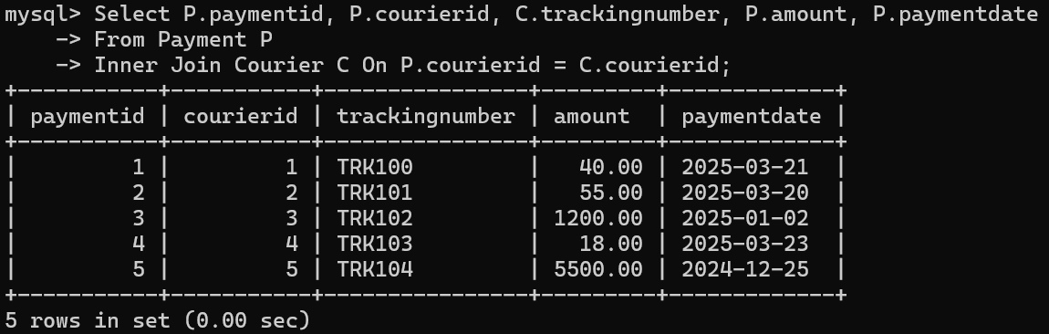

24. Retrieve Payments with Location Information

Select P.paymentid, P.locationid, L.locationname, P.amount, P.paymentdate

From Payment P

Inner Join Location L On P.locationid = L.locationid;

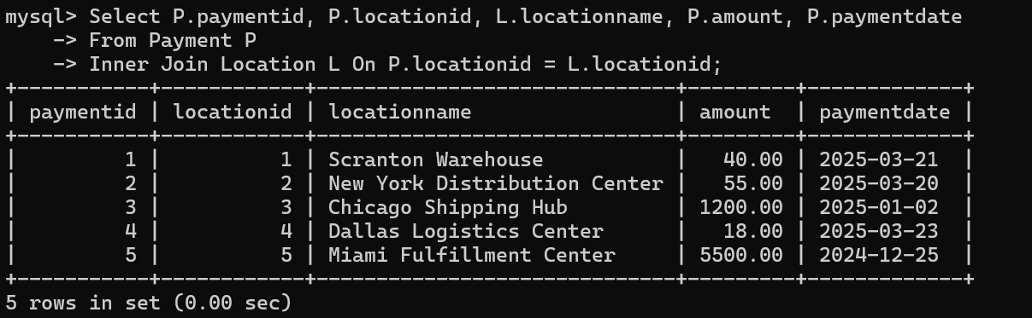

25. Retrieve Payments with Courier and Location Information

Select P.paymentid, C.trackingnumber, L.locationname, P.amount, P.paymentdate

From Payment P

Inner Join Courier C On P.courierid = C.courierid

Inner Join Location L On P.locationid = L.locationid;

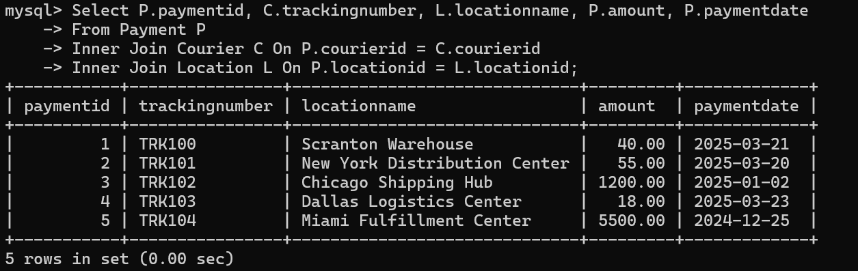

26. List all payments with courier details

Select P.*, C.sendername, C.receivername, C.weight, C.status

From Payment P

Inner Join Courier C On P.courierid = C.courierid;

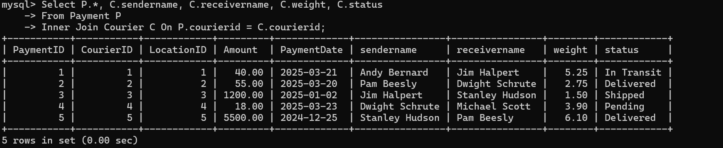

27. Total payments received for each courier

Select P.courierid, C.trackingnumber, Sum(P.amount) As Totalpayments

From Payment P

Inner Join Courier C On P.courierid = C.courierid

Group By P.courierid, C.trackingnumber;

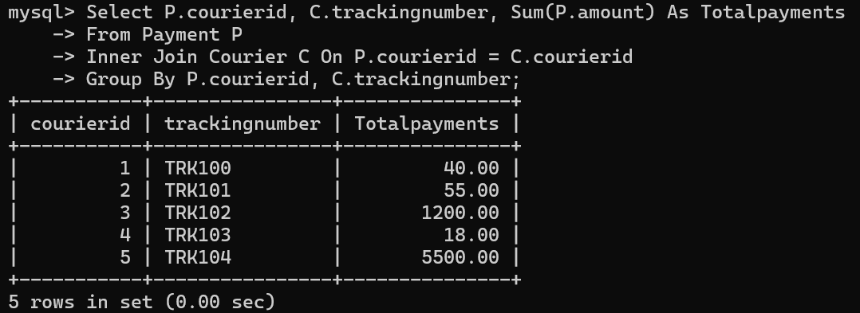

28. List payments made on a specific date

Select *

From Payment

Where Paymentdate = '2025-03-21';

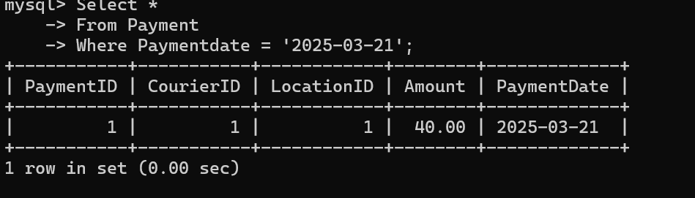

29. Get Courier Information for Each Payment

Select P.paymentid, C.courierid, C.trackingnumber, C.sendername, C.receivername, C.weight, C.status

From Payment P

Inner Join Courier C On P.courierid = C.courierid;

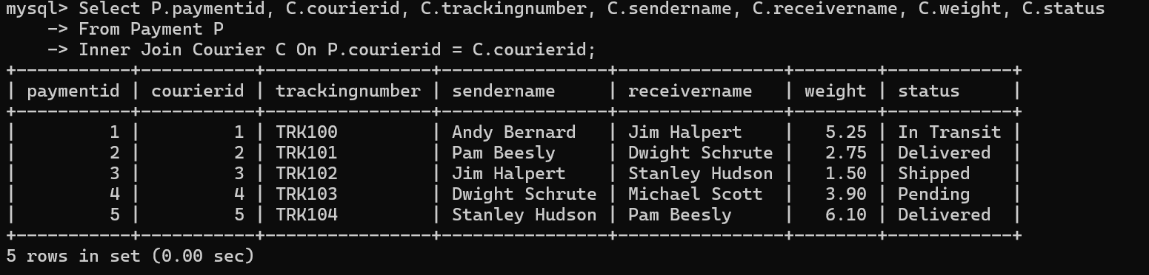

30. Get Payment Details with Location

Select P.paymentid, P.amount, P.paymentdate, L.locationid, L.locationname, L.address

From Payment P

Inner Join Location L On P.locationid = L.locationid;

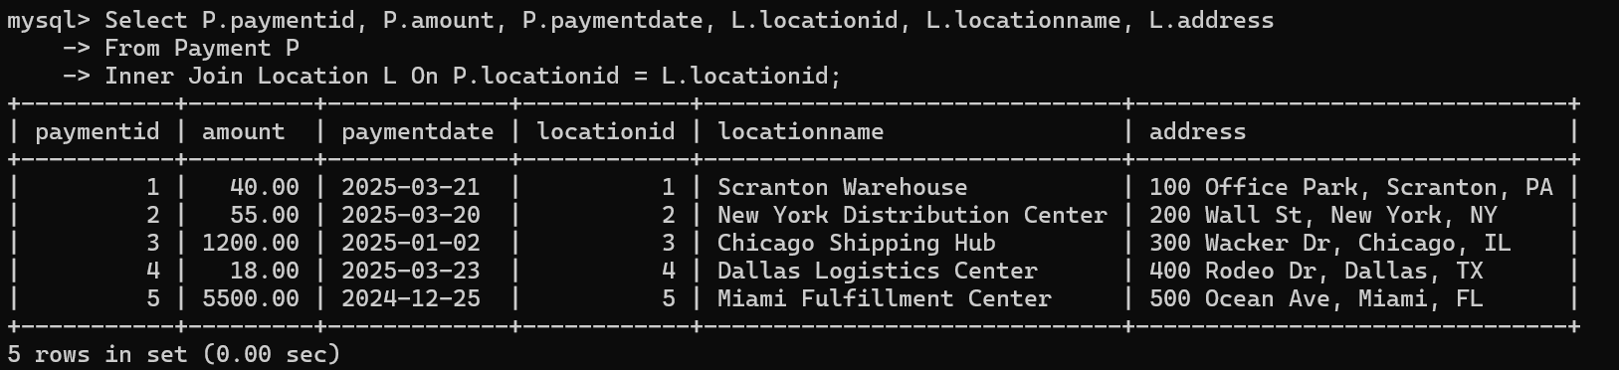

31. Calculating Total Payments for Each Courier

Select P.courierid, C.trackingnumber, Sum(P.amount) As Totalpayments

From Payment P

Inner Join Courier C On P.courierid = C.courierid

Group By P.courierid, C.trackingnumber;

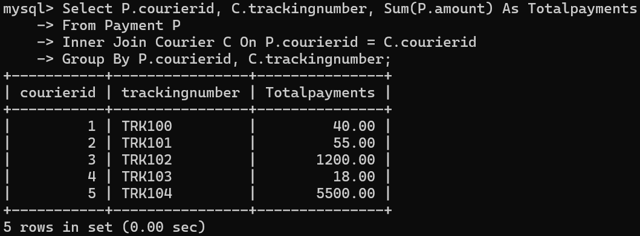

32. List Payments Within a Date Range

Select *

From Payment

Where Paymentdate Between '2025-03-01' And '2025-03-31';

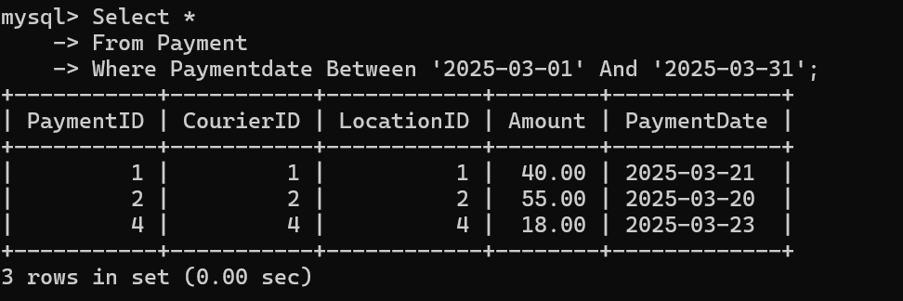

33. Retrieve a list of all users and their corresponding courier records, including cases where there are no matches on either side

Select U.userid, U.name, C.courierid, C.trackingnumber, C.status

From User U

Left Join Courier C On U.name = C.sendername

Union

Select U.userid, U.name, C.courierid, C.trackingnumber, C.status

From User U

Right Join Courier C On U.name = C.sendername;

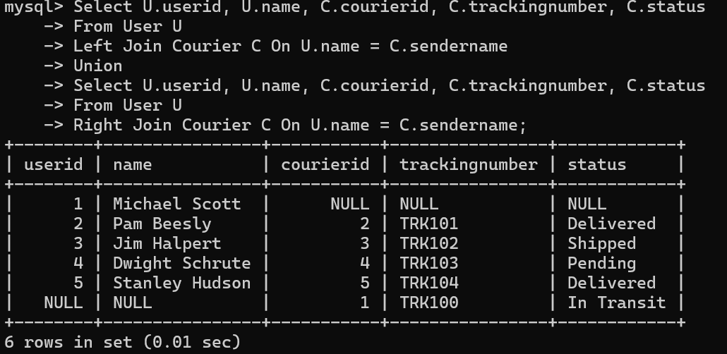

34. Retrieve a list of all couriers and their corresponding services, including cases where there are no matches on either side

Select C.courierid, C.trackingnumber, Cs.serviceid, Cs.servicename, Cs.cost

From Courier C

Left Join Courierservices Cs On C.weight <= Cs.cost

Union

Select C.courierid, C.trackingnumber, Cs.serviceid, Cs.servicename, Cs.cost

From Courier C

Right Join Courierservices Cs On C.weight <= Cs.cost;

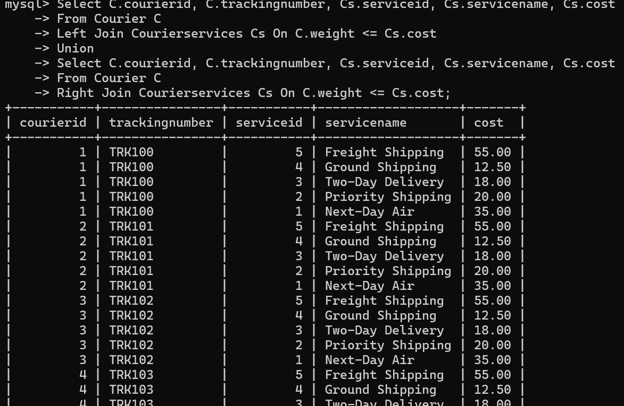

35. Retrieve a list of all employees and their corresponding payments, including cases where there are no matches on either side

Select E.employeeid, E.name, P.paymentid, P.amount, P.paymentdate

From Employee E

Left Join Payment P On E.name = P.courierid

Union

Select E.employeeid, E.name, P.paymentid, P.amount, P.paymentdate

From Employee E

Right Join Payment P On E.name = P.courierid;

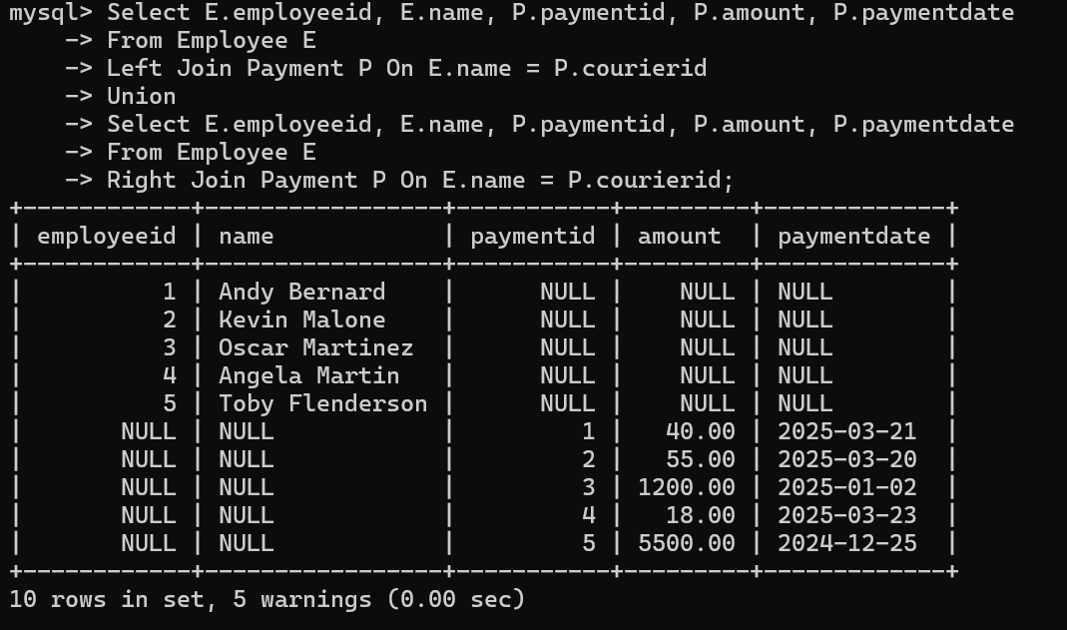

36. List all users and all courier services, showing all possible combinations.

Select U.userid, U.name, Cs.serviceid, Cs.servicename

From User U

Cross Join Courierservices Cs;

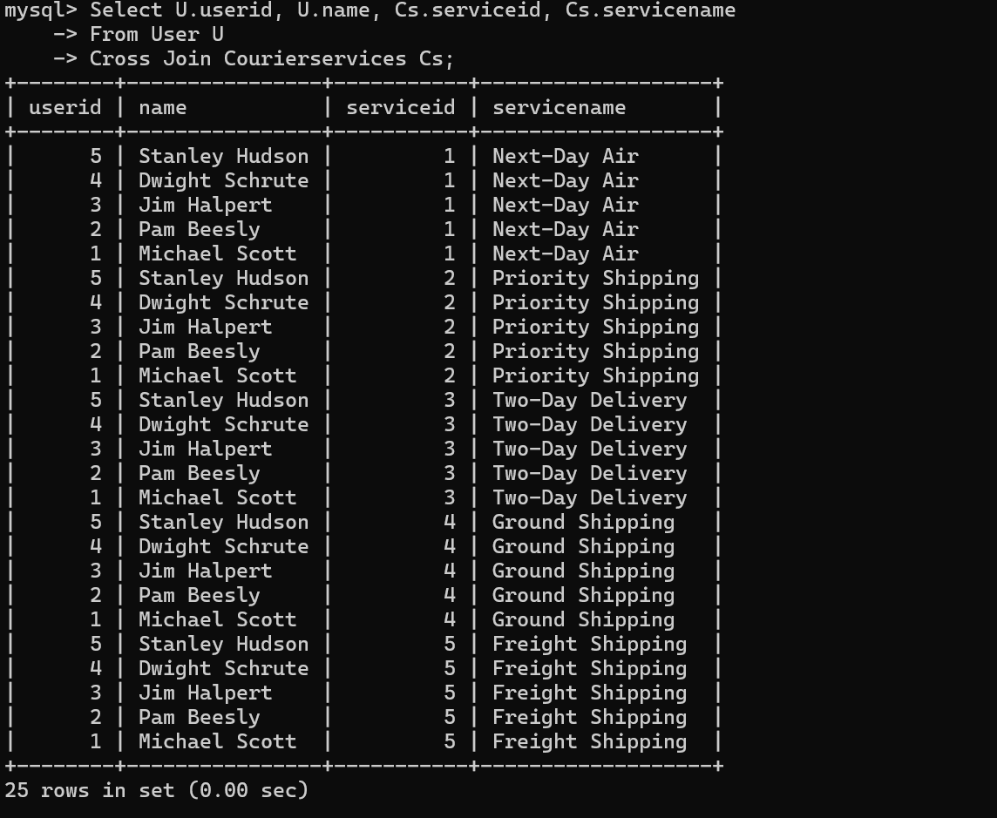

37. List all employees and all locations, showing all possible combinations:

Select E.employeeid, E.name, L.locationid, L.locationname

From Employee E

Cross Join Location L;

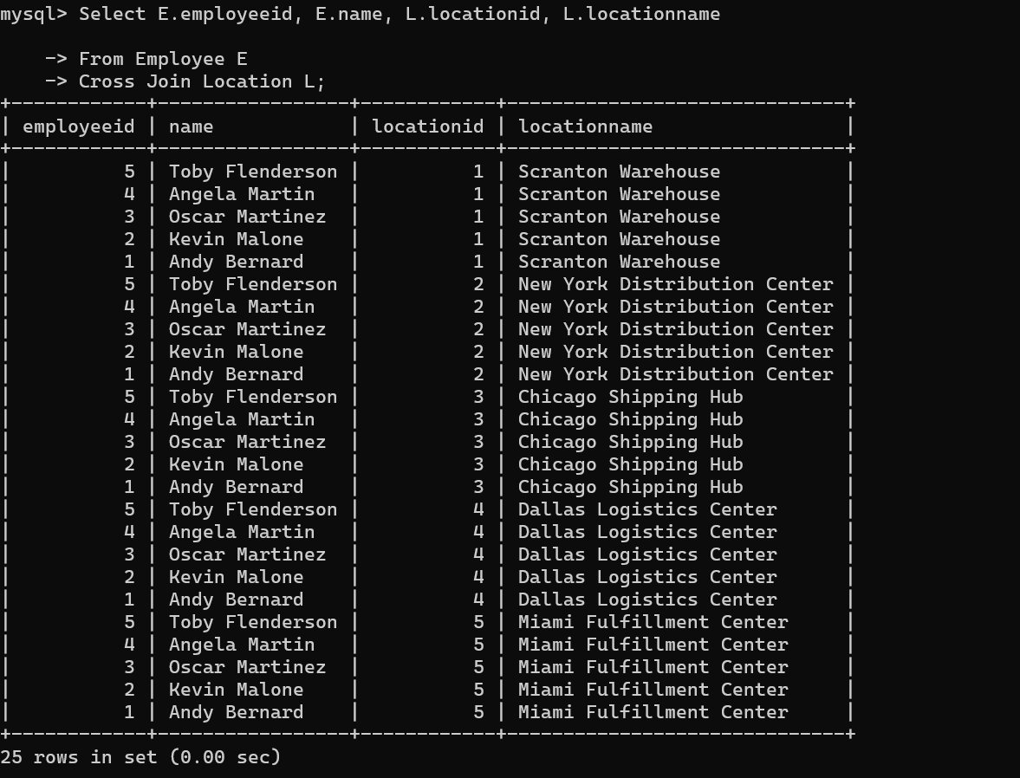

38. Retrieve a list of couriers and their corresponding sender information (if available)

Select C.courierid, C.trackingnumber, U.name As Sendername, U.address As Senderaddress

From Courier C

Left Join User U On C.sendername = U.name;

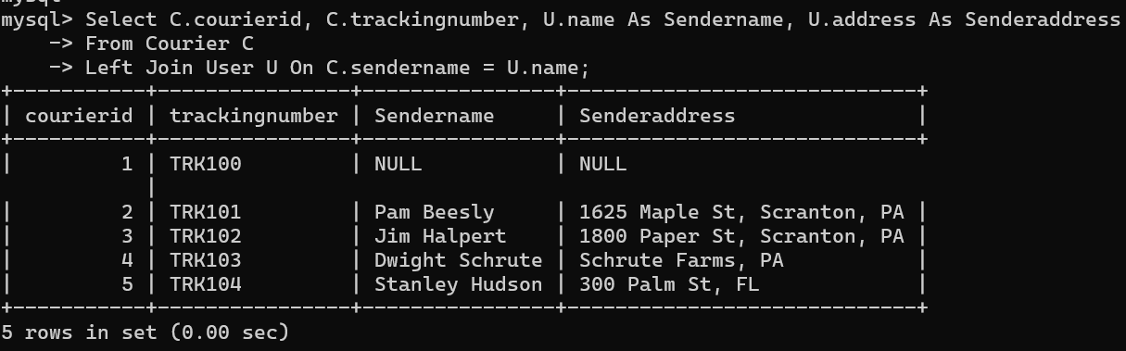

39. Retrieve a list of couriers and their corresponding receiver information (if available):

Select C.courierid, C.trackingnumber, Cs.serviceid, Cs.servicename, Cs.cost

From Courier C

Left Join Courierservices Cs On C.weight <= Cs.cost;

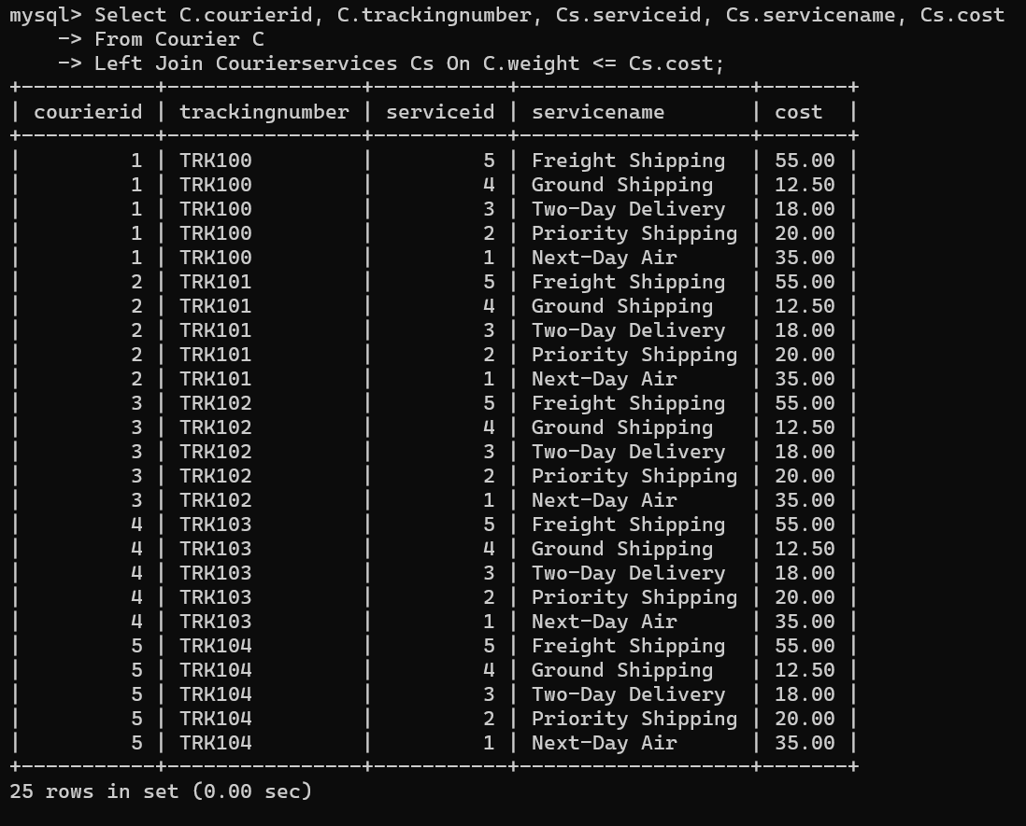

40. Retrieve a list of couriers along with the courier service details (if available):

Select C.courierid, C.trackingnumber, Cs.serviceid, Cs.servicename, Cs.cost

From Courier C

Left Join Courierservices Cs On C.weight <= Cs.cost;

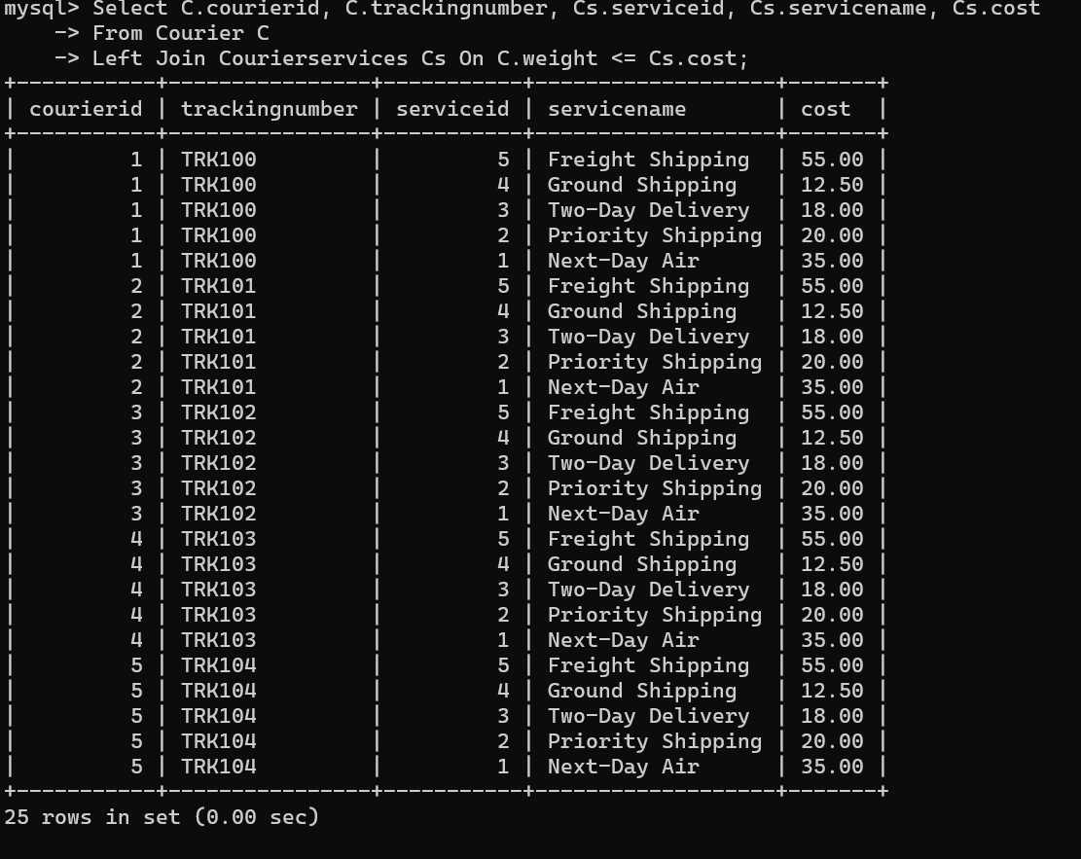

41. Retrieve a list of employees and the number of couriers assigned to each employee:

Select E.employeeid, E.name, Count(C.courierid) As Totalcouriers

From Employee E

Left Join Courier C On E.name = C.sendername

Group By E.employeeid, E.name;

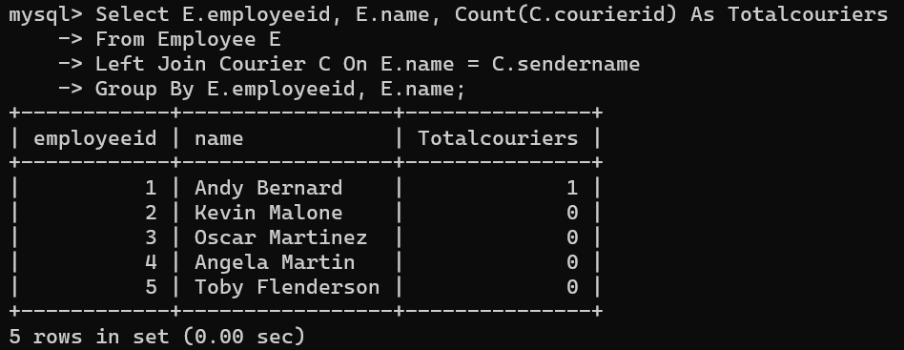

42. Retrieve a list of locations and the total payment amount received at each location:

Select L.locationid, L.locationname, Sum(P.amount) As Totalpayments

From Location L

Left Join Payment P On L.locationid = P.locationid

Group By L.locationid, L.locationname;

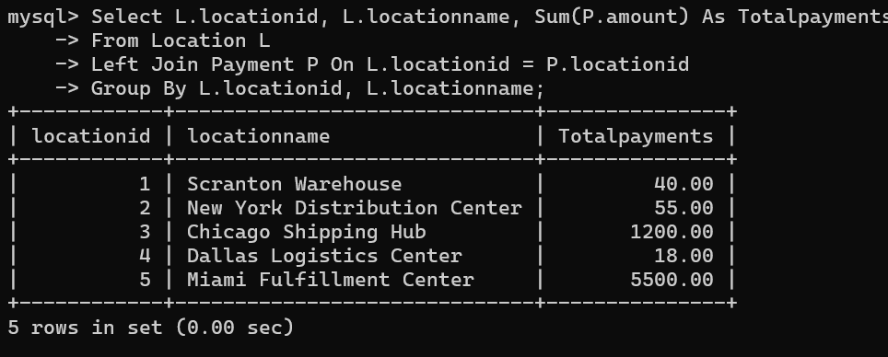

43. Retrieve all couriers sent by the same sender (based on SenderName).

Select L.locationid, L.locationname, Sum(P.amount) As Totalpayments

From Location L

Left Join Payment P On L.locationid = P.locationid

Group By L.locationid, L.locationname;

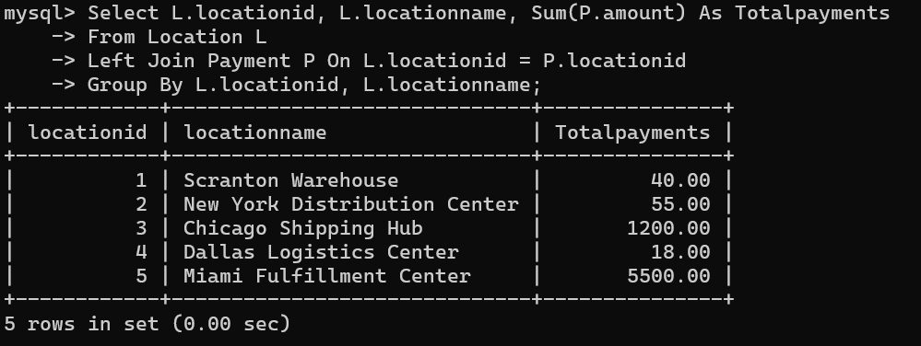

44. List all employees who share the same role.

Select E1.employeeid, E1.name, E1.role

From Employee E1

Where E1.role In (

Select E2.role

From Employee E2

Group By E2.role

Having Count(*) > 1

);

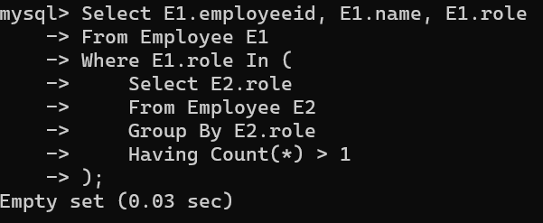

45. Retrieve all payments made for couriers sent from the same location.

Select P.paymentid, C.courierid, C.senderaddress, P.amount

From Payment P

Join Courier C On P.courierid = C.courierid

Where C.senderaddress In (

Select C2.senderaddress

From Courier C2

Group By C2.senderaddress

Having Count(*) > 1

);

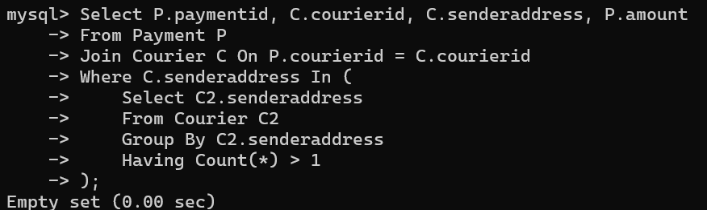

46. Retrieve all couriers sent from the same location (based on SenderAddress).

Select C.courierid, C.trackingnumber, C.senderaddress

From Courier C

Where C.senderaddress In (

Select C2.senderaddress

From Courier C2

Group By C2.senderaddress

Having Count(*) > 1

);

47. List employees and the number of couriers they have delivered:

Select E.employeeid, E.name, Count(C.courierid) As Totaldelivered

From Employee E

Left Join Courier C On E.name = C.sendername

Where C.status = 'delivered'

Group By E.employeeid, E.name;

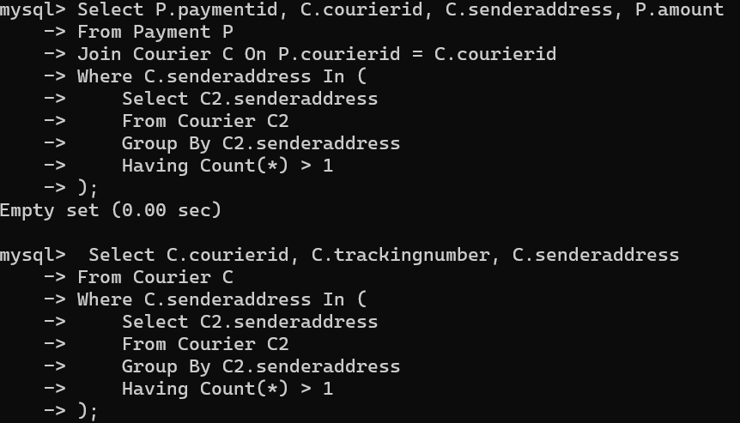

48. Find couriers that were paid an amount greater than the cost of their respective courier services

Select C.courierid, C.trackingnumber, P.amount, Cs.cost

From Courier C

Join Payment P On C.courierid = P.courierid

Join Courierservices Cs On C.weight <= Cs.cost

Where P.amount > Cs.cost;

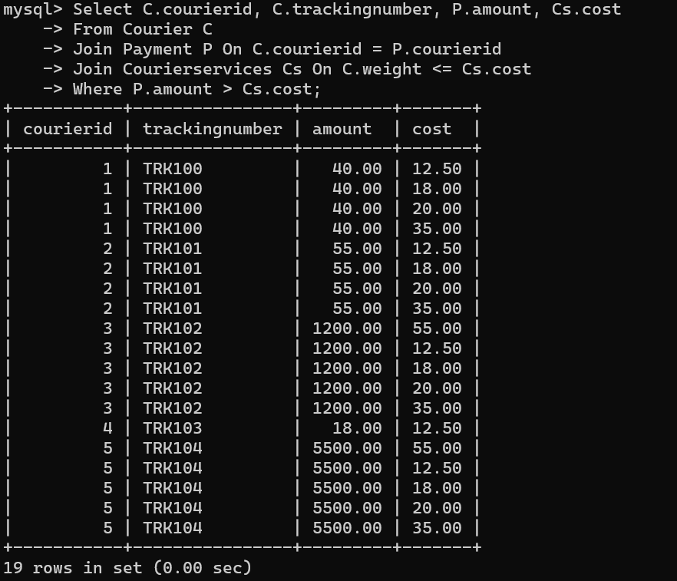

**Scope: Inner Queries, Non Equi Joins, Equi joins,Exist,Any,All**

49. Find couriers that have a weight greater than the average weight of all couriers

select courierid, trackingnumber, weight

from courier

where weight > (select avg(weight) from courier);

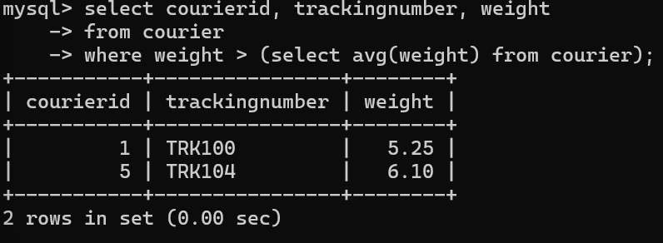

50. Find the names of all employees who have a salary greater than the average salary:

select employeeid, name, salary

from employee

where salary > (select avg(salary) from employee);

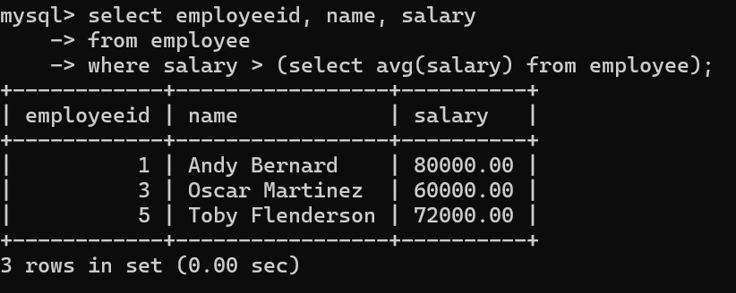

51. Find the total cost of all courier services where the cost is less than the maximum cost

select sum(cost) as totalcost

from courierservices

where cost < (select max(cost) from courierservices);

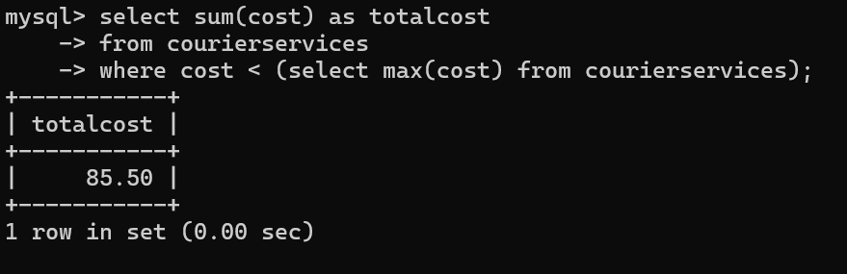

52. Find all couriers that have been paid for

select c.courierid, c.trackingnumber, p.amount, p.paymentdate

from courier c

join payment p on c.courierid = p.courierid;

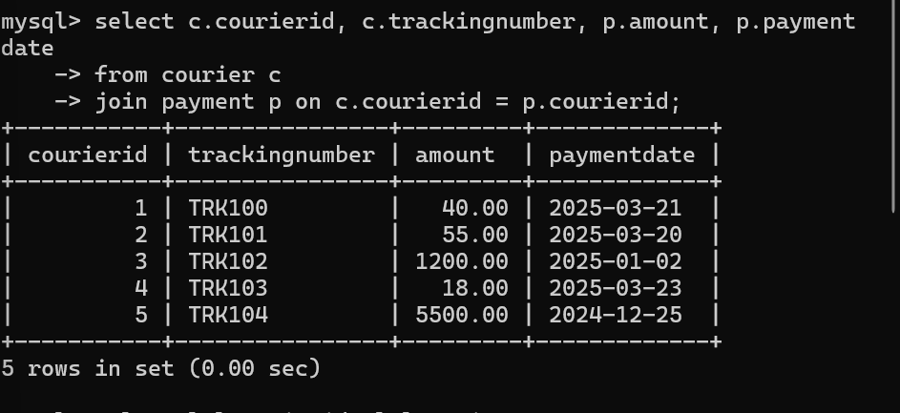

53. Find the locations where the maximum payment amount was made

select l.locationid, l.locationname, p.amount

from location l

join payment p on l.locationid = p.locationid

where p.amount = (select max(amount) from payment);

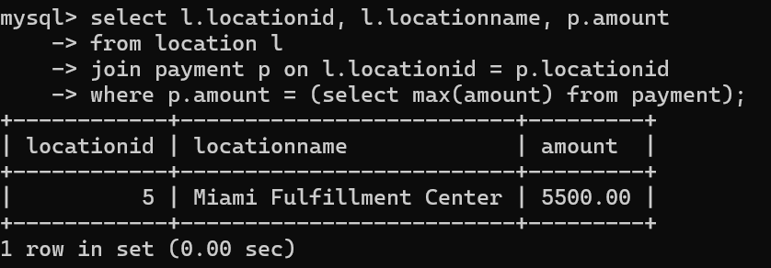

54. Find all couriers whose weight is greater than the weight of all couriers sent by a specific sender

(e.g., 'SenderName'):

select c.courierid, c.trackingnumber, c.weight

from courier c

where c.weight > all (

select c2.weight

from courier c2

where c2.sendername = 'michael scott'

);

